**DESCRIPTION OF PREVENTIVE MAINTAINENCE TASK**

**Preventive Maintenance task :**

The thought to prevent CNC machine from the production worries Preventive maintenance helps save time and money by keeping the machine running at peak performance. A planned preventative maintenance program can help you catch minor issues before they cause major breakdowns.

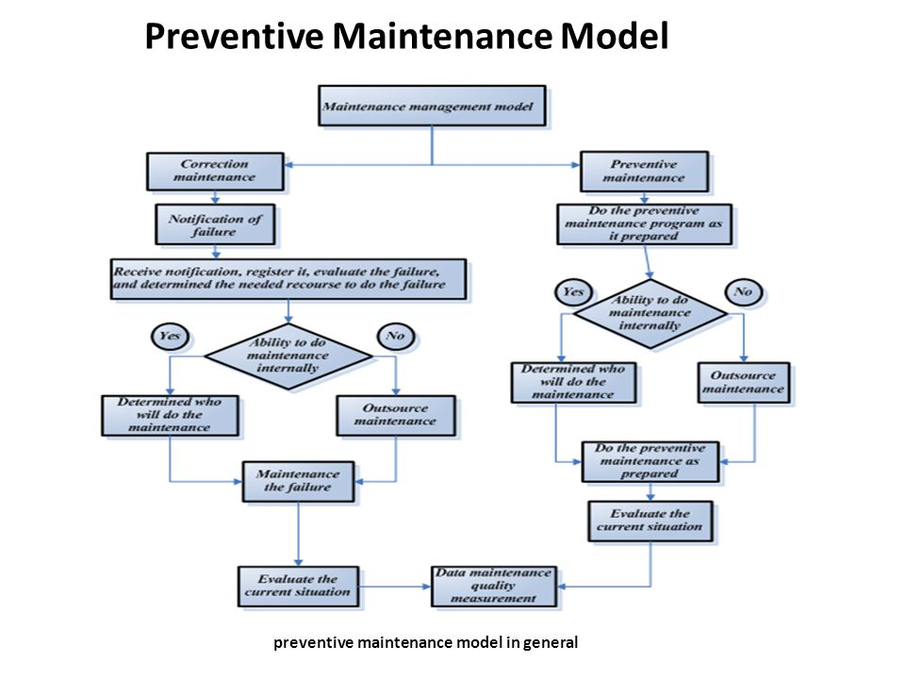

**Benefits of preventive maintenance task**

1. Help to steadily increase the profitability of your company
2. Prevent and reduce machine and production downtime
3. Improve and keep the productivity of the machine tool
4. Extend the lifespan of both your machines and cutting tools
5. Minimize or eliminate crashes or accidents that can be dangerous for operators
6. Increase efficiency by using less material and reducing scrap materials
7. Reduce and avoid hefty repair costs from unexpected break down of your machines

**DAILY CARE AND FEEDING OF YOUR CNC MACHINE:**

1. Check on levels of coolant
2. Check on the cutting tool at ATC
3. Check on hydraulic systems for any leakage
4. Check on air supply to make sure that it is clean and dry
5. Check for any leakage or strange sounds
6. Lubricate machine’s moving parts
7. Ensure that spindles, chucks and any moving parts are cleaned by brushes or flushed with coolant.
8. Check on pneumatic pumps and chucks.
9. Ensure that chips are cleaned but not blown off to prevent damage.

**EVERY THREE MONTHS OR 500 HOURS**

1. Check and grease the chain on the chip conveyor
2. Check and clean the filters on the coolant tank

**EVERY SIX MONTHS OR 1000 HOURS**

1. Have the coolant tank cleaned of sludge, chips, and oil
2. Have the chuck and jaws taken off the machine and cleaned
3. Have the leveling of your machine checked and adjusted if necessary
4. Have the radiator cleaned while making sure that the radiator fins are straight and not damaged
5. Have all way wipers inspected for any damage – clean and replace any wipers that are damaged
6. Have the hydraulic tank drained, and replace the hydraulic oil with fresh hydraulic oil. Do also ensure that the line filter and suction filter are changed.
7. Have the lubrication unit drained and cleaned out – thereafter you should add fresh way lubricant
8. If your machine is equipped with a cooling unit, have the cooling unit drained and refilled

**ONCE A YEAR OR EVERY 2000 HOURS**

1. Have the spindle checked for radial and end play issues
2. Have the chuck cylinder checked for run out
3. Have the tailstock checked for misalignments and quill function
4. Have the turret parallelism and inclination checked
5. Have the whole machine checked for leakage of oil or air
6. Have the headstock checked for any damage or misalignments, and the spindle taper at milling machines
7. Have your distributor / supplier check the X, Y and Z axis gibs and adjust if necessary. Check in the same way the function of your 4th axis table
8. Have your distributor / supplier run a backlash program to check the backlash in X, Y and Z axis and adjust if necessary